Database Management and Database Design

Assignment 1

Date: 12-Sept-2019

Name Jayshil Jain

NUID: 001300508

1. Install SQL server and SQL Management Studio

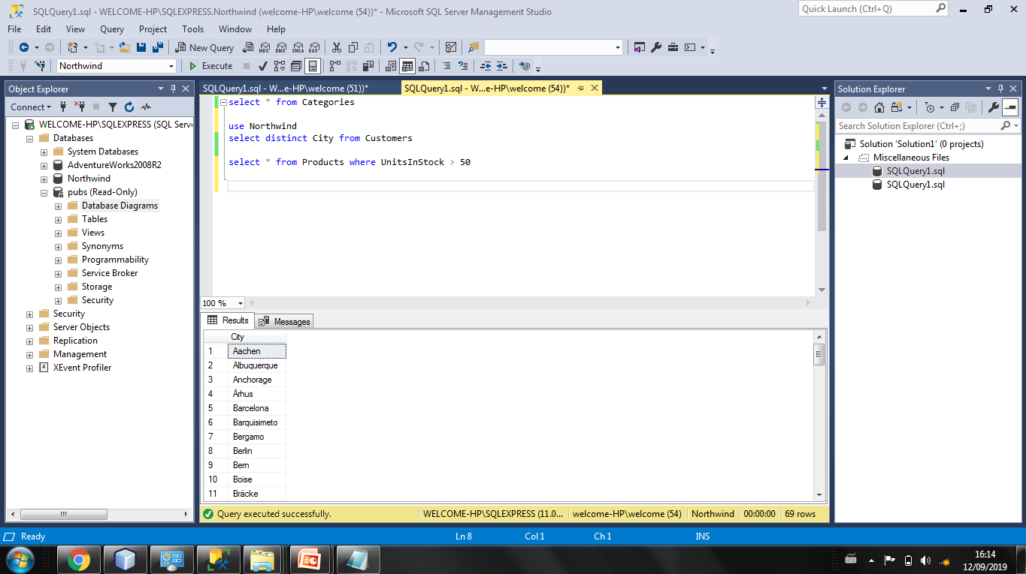

1. Restore sample database(AdventureWorks)

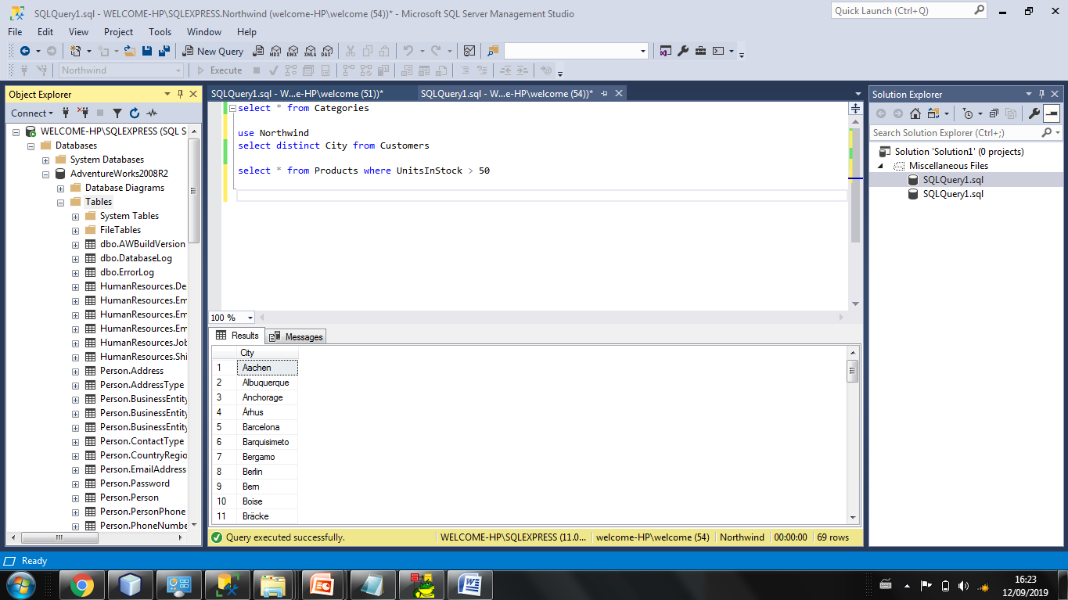

1. Restore sample database (NorthWinds)

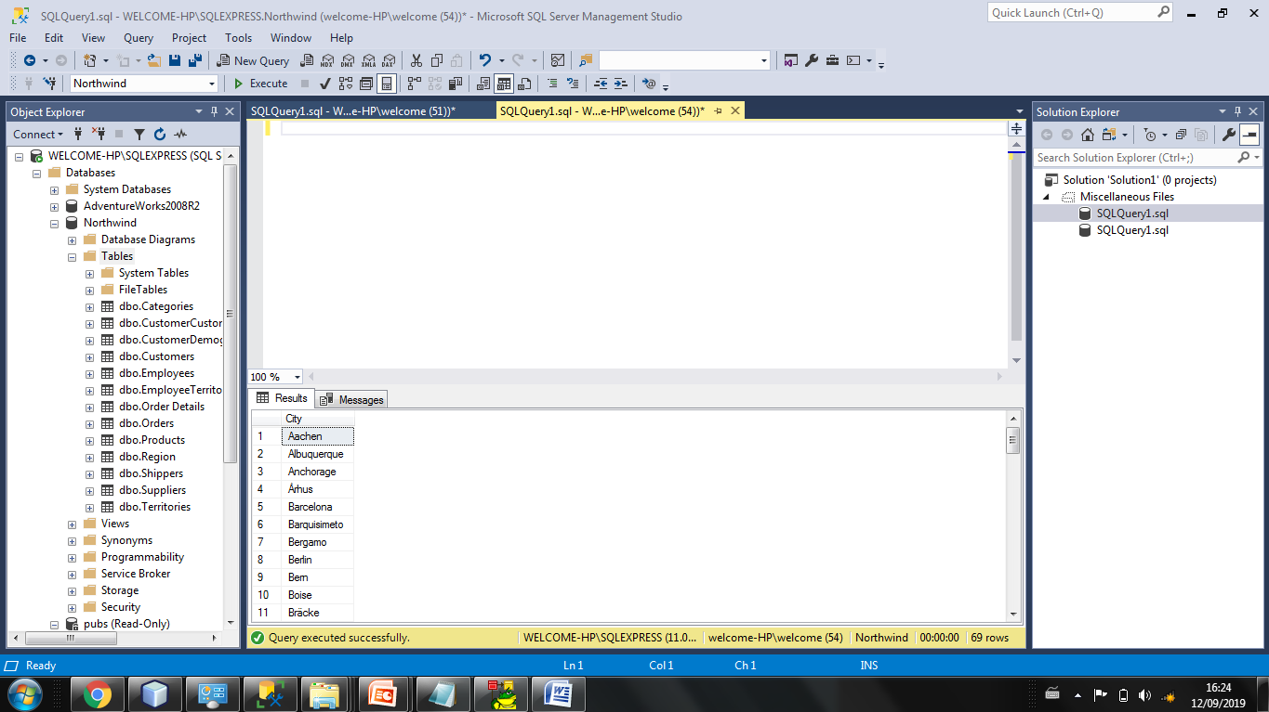

1. Restore sample database (Pubs)

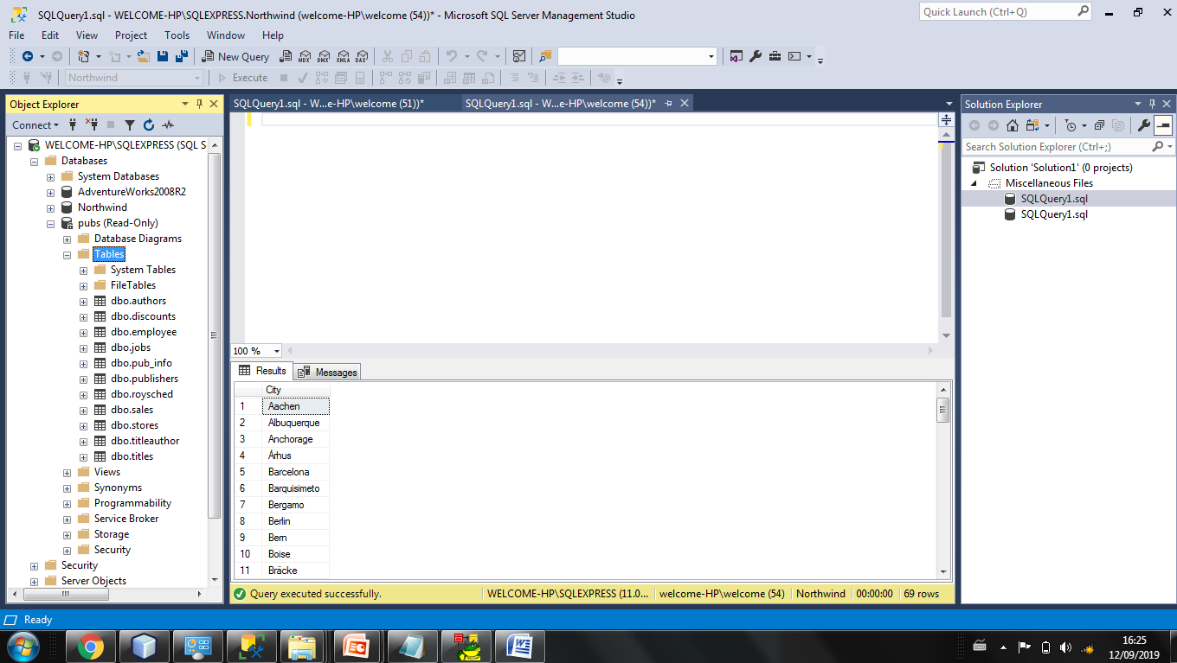

1. Install Toad data Modeller

